Spring 2023: CS5710 – Machine Learning
In-Class Programming Assignment-3
GitHub Link - https://github.com/raimukul/MachineLearning_Assignments
Video link- https://drive.google.com/file/d/12AmiOel5rgY9Ox13Js-YWO1owgW-GTqZ/view?usp=sharing

1. Numpy:

a. Using NumPy, create a random vector of size 15 with only Integers in the range 1-20.
- Reshape the array to 3 by 5
- Print array shape.
- Replace the max in each row by 0.
Create a 2-dimensional array of size 4 x 3 (composed of 4-byte integer elements), also print the shape, type and data type
of the array.
b. Write a program to compute the eigenvalues and right eigenvectors of a given square array given below:
[[ 3 -2]
[ 1 0]]
c. Compute the sum of the diagonal element of a given array.
[[0 1 2]
[3 4 5]]

d. Write a NumPy program to create a new shape to an array without changing its data. Reshape 3x2:
[[1 2]
[3 4]
[5 6]]

Reshape 2x3:
[[1 2 3]
[4 5 6]]

import numpy as npy;

# 1.a
vector = npy.random.randint(1, 20, 15)
print ("1.a Vector: ", vector)
# 1.a.1 Reshape the array to 3 by 5
reshaped = vector.reshape(3, 5)

1.a Vector: [ 1 11 15 3 15 7 1 5 7 9 6 4 6 12 19]

# 1.a.2 Print array shape.
print ("1.a.2 Reshaped array shape: ", reshaped.shape)

1.a.2 Reshaped array shape: (3, 5)

# 1.a.3 Replace the max in each row by 0.
for i in range(reshaped.shape[0]):
reshaped[i, npy.where(reshaped[i] == reshaped[i].max())] = 0
print ("1.a.3 Replaced max in each row by 0: \n", reshaped)

1.a.3 Replaced max in each row by 0:
[[ 1 11 0 3 0]
[ 7 1 5 7 0]
[ 6 4 6 12 0]]

# 1.b compute the eigenvalues and right eigenvectors of a given square array
array = npy.random.randint(1, 20, (4, 3), dtype=npy.int32)
print ("1.b Array: \n", array)
print ("1.b Array shape: ", array.shape)
print ("1.b Array type: ", type(array))
print ("1.b Array data type: ", array.dtype)

1.b Array:
[[13 6 3]
[ 7 19 9]
[17 3 5]
[ 8 11 1]]
1.b Array shape: (4, 3)
1.b Array type: <class 'numpy.ndarray'>
1.b Array data type: int32

# 1.b
newArray = npy.array([[3, -2], [1, 0]])
eigenvalues, eigenvectors = npy.linalg.eig(newArray)
print ("1.b Eigenvalues: \n", eigenvalues)
print ("1.b Eigenvectors: \n", eigenvectors)

1.b Eigenvalues:
[2. 1.]
1.b Eigenvectors:
[[0.89442719 0.70710678]
[0.4472136 0.70710678]]

# 1.c sum of the diagonal element of a given array:
oneC = npy.array([[0, 1, 2], [3, 4, 5]])
print ("1.c Array: \n", oneC)
print ("1.c Sum of diagonal elements: ", npy.trace(oneC))

1.c Array:
[[0 1 2]
[3 4 5]]
1.c Sum of diagonal elements: 4

# 1.d new shape to an array without changing its data. Reshape 3x2:
oneD = npy.arange(1, 7)
print ("1.d Array: ", oneD)
# reshape to 3x2
oneD = oneD.reshape(3, 2)
print ("1.d Reshaped array 3x2: \n", oneD)
# reshape to 2x3
oneD = oneD.reshape(2, 3)
print ("1.d Reshaped array 2x3: \n", oneD)

1.d Array: [1 2 3 4 5 6]
1.d Reshaped array 3x2:
[[1 2]
[3 4]
[5 6]]
1.d Reshaped array 2x3:
[[1 2 3]
[4 5 6]]

2. Matplotlib
- Write a Python programming to create a below chart of the popularity of programming Languages.
- Sample data:
Programming languages: Java, Python, PHP, JavaScript, C#, C++
Popularity: 22.2, 17.6, 8.8, 8, 7.7, 6.7

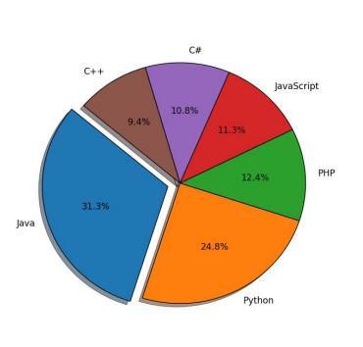

#2
import matplotlib.pyplot as plt

programmingLanguages = ['Java', 'Python', 'PHP', 'JavaScript', 'C#', 'C++']
popularity = [22.2, 17.6, 8.8, 8, 7.7, 6.7]
dictionary = dict(zip(programmingLanguages, popularity))
dictionary = dict(sorted(dictionary.items(), key=lambda item: item[1], reverse=True))
explode = (0.1, 0, 0, 0, 0, 0)
plt.pie(dictionary.values(), labels=dictionary.keys(), explode=explode, autopct='%1.1f%%', shadow=True, startangle=135)
plt.axis('equal')
plt.show()

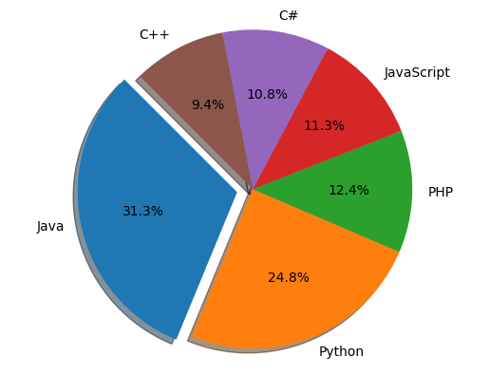

Screenshots:
